Server 2022 Worksheet
The purpose of this worksheet is to guide you towards successfully promoting your Server 2022 to an Active Directory (AD) Domain Controller

Instructions
- Start your Server 2022 virtual machine. You can use either your VirtualBox installation or your Team Server on ProxMox.
  - If you are using VirtualBox, make sure Server 2022 is connected to the same NAT Network you used in the previous project (week 3-project #8).
    - If it isn’t, go to the VM’s settings and change the network adapter to use the correct NAT Network.
  - Optional: check your Windows 11 VM’s network settings and make sure it is connected to the same NAT Network. It doesn’t need to be powered on for this project.
- Open a Command Prompt and take a screenshot of ipconfig results.

Sample Screenshot
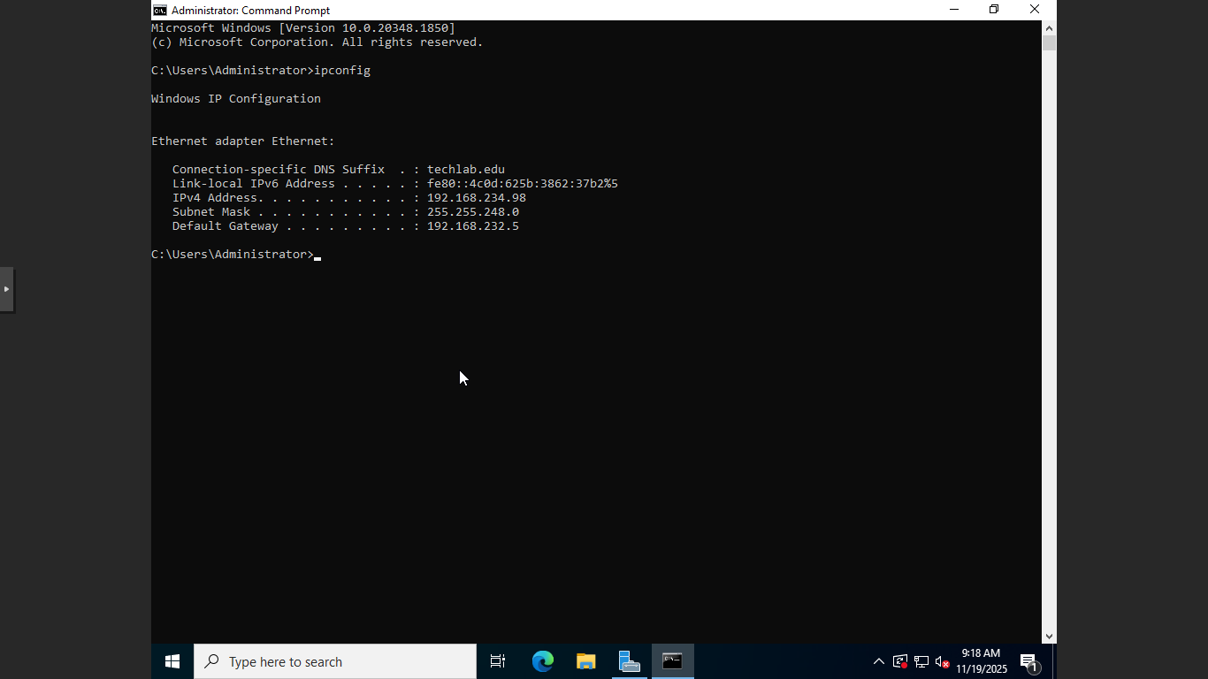
Delete the Sample Screenshot and paste YOUR screenshot here. (Do NOT use the sample screenshot.)

- Open Server Manager and open the Local Server page. Take a screenshot of the Local Server page.
Sample Screenshot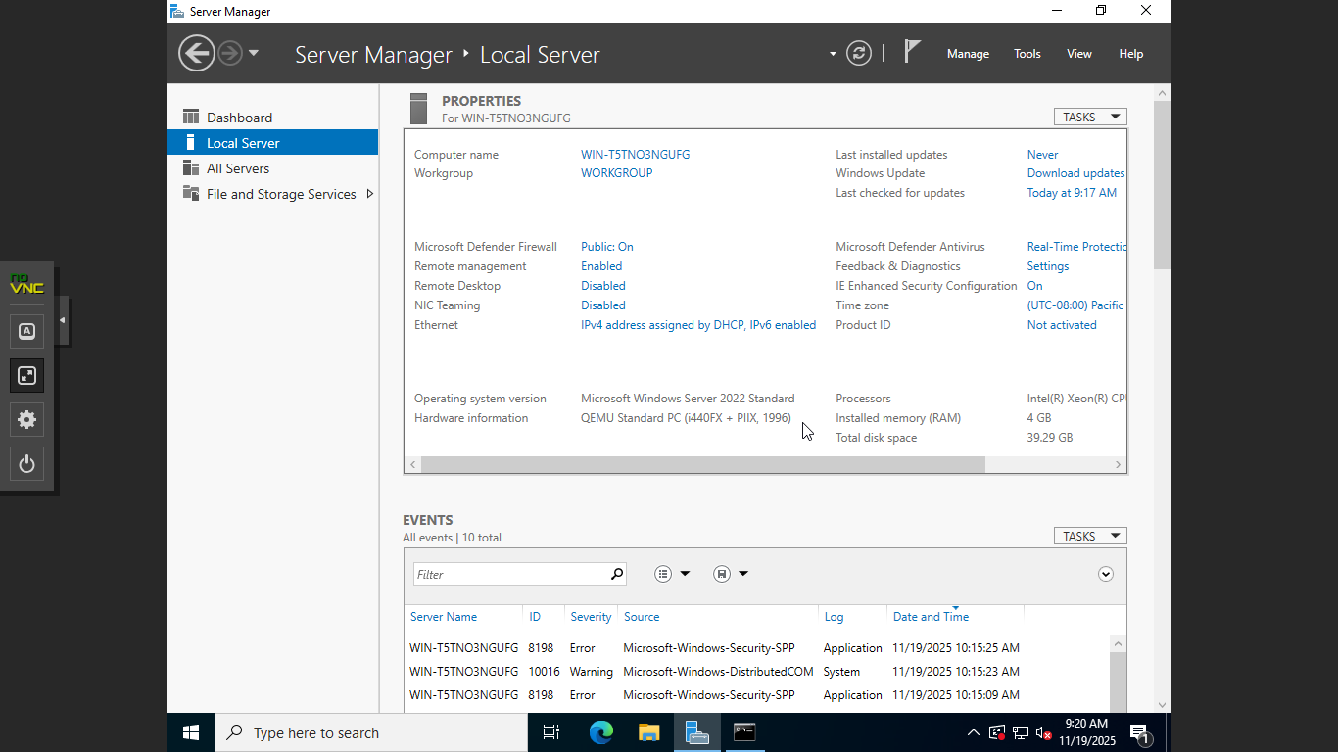
Delete the Sample Screenshot and paste YOUR screenshot here. (Do NOT use the sample screenshot.)

- Promote your server to a Domain Controller by creating a new Active Directory (AD) Domain.
  - You can name your domain anything you choose.
  - Keep the domain name 15 characters or fewer, and use a .local or .internal suffix (e.g., Team1.local).
  - If you are using ProxMox, make sure all group members are monitoring the promotion.
  - If you have done this before and feel confident, proceed. Otherwise, reference an online tutorial for creating an Active Directory (AD) Domain. Here are two suggestions:
    - Read: Promote a Server to a Domain Controller (URL: (https://www.serveracademy.com/blog/promote-a-server-to-a-domain-controller/)
    - Watch: How to promote Windows Server 2022 to be a Domain Controller.
  - If you have any problems, please communicate with the instructor or fellow students!
- Take a screenshot of the Local Server page from Server Manager after creating your domain controller.
Sample Screenshot
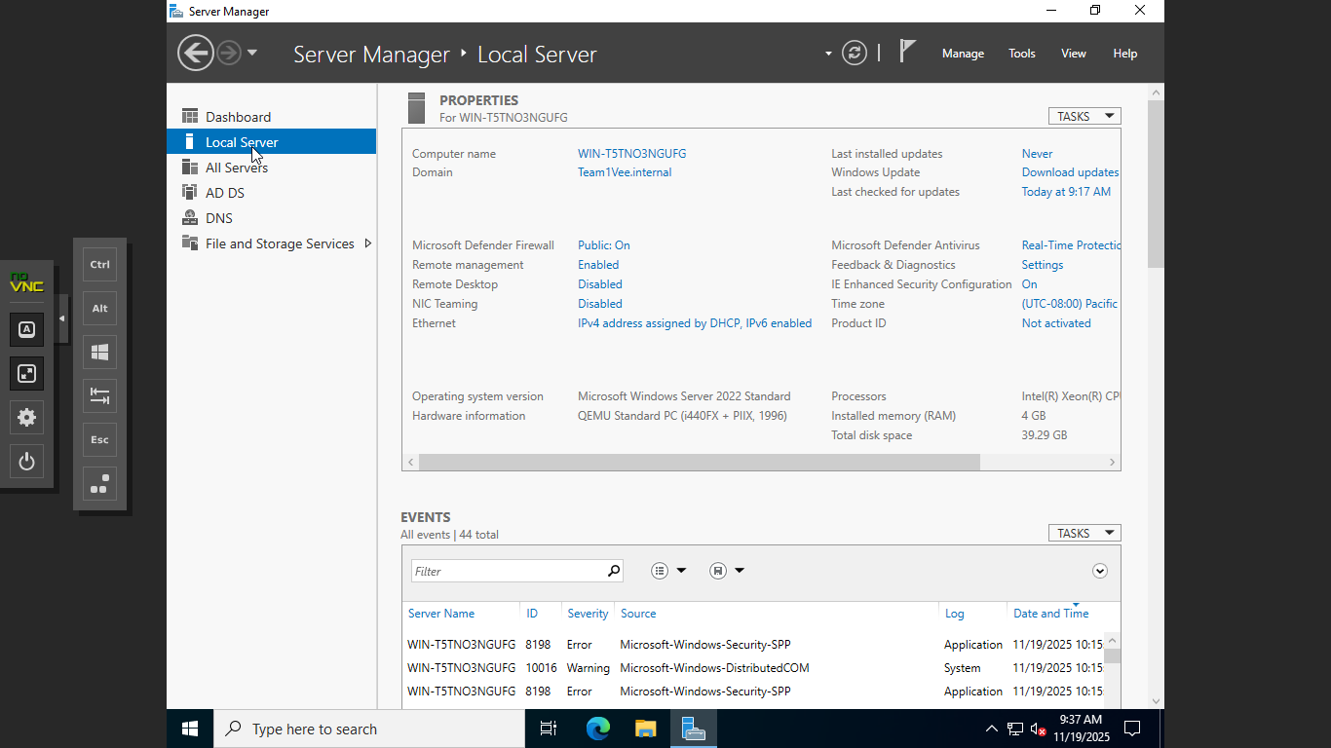
Delete the Sample Screenshot and paste YOUR screenshot here. (Do NOT use the sample screenshot.)

- Save and submit this completed worksheet in Canvas. Be sure you have included all of your required screenshots (steps 2, 3, and 5).

